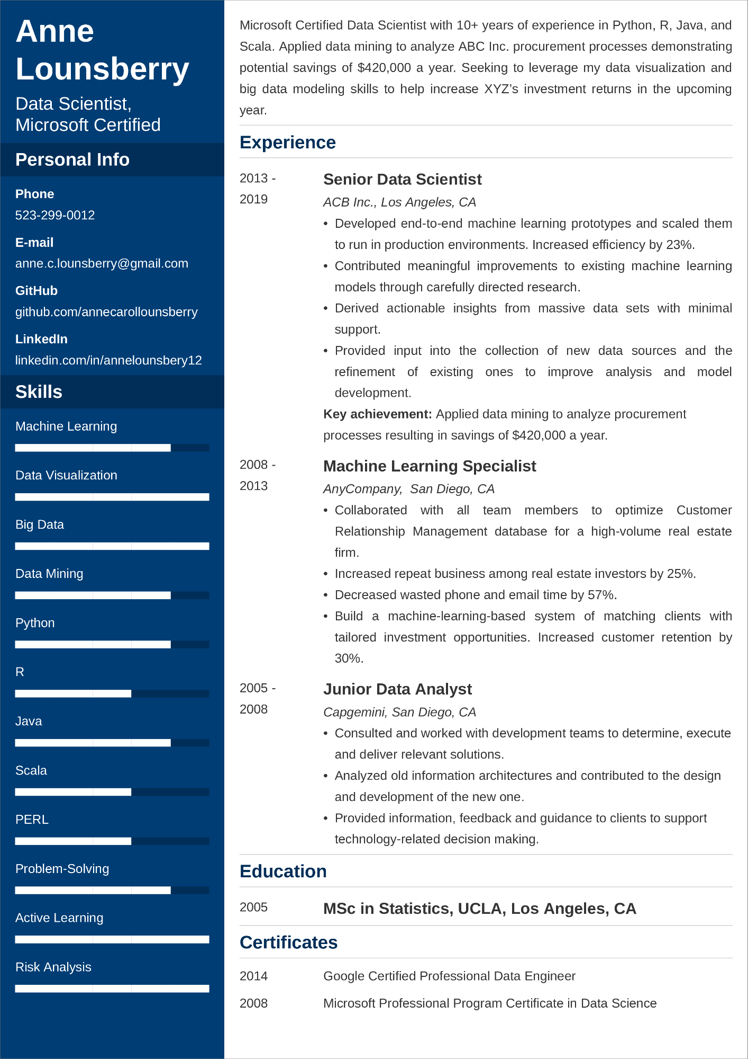
Anne Lounsberry
Data Scientist,
Microsoft Certified
Personal Info
Phone
523-299-0012
E-mail
anne.c.lounsberry@gmail.com
GitHub
github.com/annecarollounsberry
LinkedIn
linkedin.com/in/annelounsbery12
Skills
Machine Learning
Microsoft Certified Data Scientist with 10+ years of experience in Python, R, Java, and Scala. Applied data mining to analyze ABC Inc. procurement processes demonstrating potential savings of $420,000 a year. Seeking to leverage my data visualization and big data modeling skills to help increase XYZ's investment returns in the upcoming year.
Experience
2013 -
2019
2008 -
Data Visualization
2013
Big Data
Data Mining
Python
R
Java
Scala
PERL
2005 -
2008
Senior Data Scientist
ACB Inc., Los Angeles, CA
•
•
•
Developed end-to-end machine learning prototypes and scaled them to run in production environments. Increased efficiency by 23%. Contributed meaningful improvements to existing machine learning models through carefully directed research.
Derived actionable insights from massive data sets with minimal support.
Provided input into the collection of new data sources and the refinement of existing ones to improve analysis and model development.
Key achievement: Applied data mining to analyze procurement
processes resulting in savings of $420,000 a year.
Machine Learning Specialist
AnyCompany, San Diego, CA
•
•
Collaborated with all team team members to optimize Customer Relationship Management database for a high-volume real estate
firm.
Increased repeat business among real estate investors by 25%.
• Decreased wasted phone and email time by 57%.
• Build a machine-learning-based system of matching clients with
tailored investment opportunities. Increased customer retention by 30%.
Junior Data Analyst
Capgemini, San Diego, CA
•
•
Consulted and worked with development teams to determine, execute and deliver relevant solutions.
Analyzed old information architectures and contributed to the design and development of the new one.
Provided information, feedback and guidance to clients to support technology-related decision making.
Problem-Solving
Active Learning
Education
2005
MSc in Statistics, UCLA, Los Angeles, CA
Certificates
Google Certified Professional Data Engineer
Risk Analysis
2014
2008
Microsoft Professional Program Certificate in Data Science

